# BOM:

|  |  |  |
| --- | --- | --- |
| Name | Details | Quantity |
| Back brackets | Files/Brackets | 2 |
| Standoff clip | Files/Misc | 1 |
| Bandage | Files/Bottom panel | 8 |
| Bottom panel - 1 | Files/Bottom panel | 1 |
| Bottom panel - 2 | Files/Bottom panel | 1 |
| Bottom panel - 3 | Files/Bottom panel | 1 |
| Bottom panel - 4 | Files/Bottom panel | 1 |
| Bottom panel - PSU | Files/Bottom panel | 1 |
| M3 Standoff | Male-Female type, 14mm body, 6mm thread | 3 |
| M3 heatset insert |  | 10 |

# Print settings

- Brims: disabled  
- Supports: disabled  
- Notes: get your first layer dialed in! the bottom plates’ quality depends on it

# Installation guide

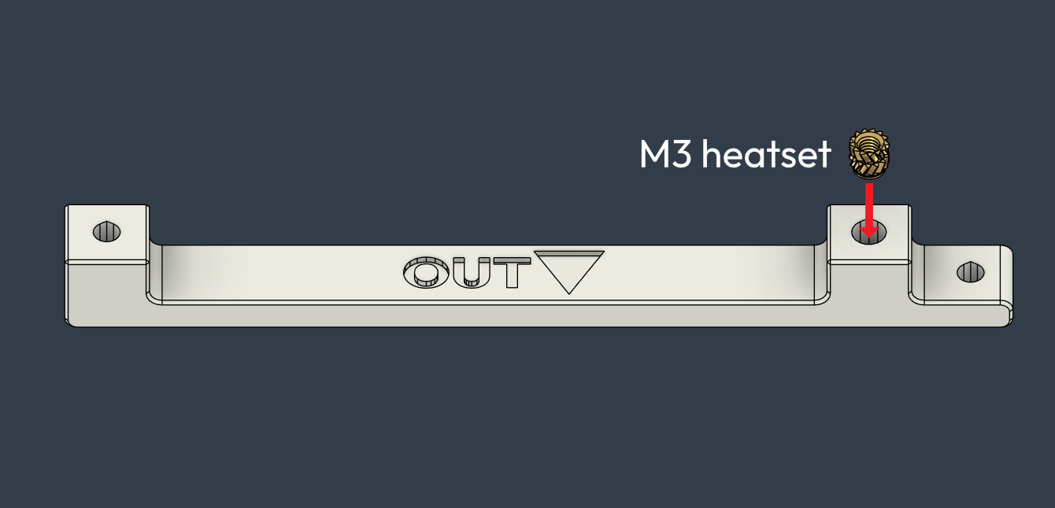

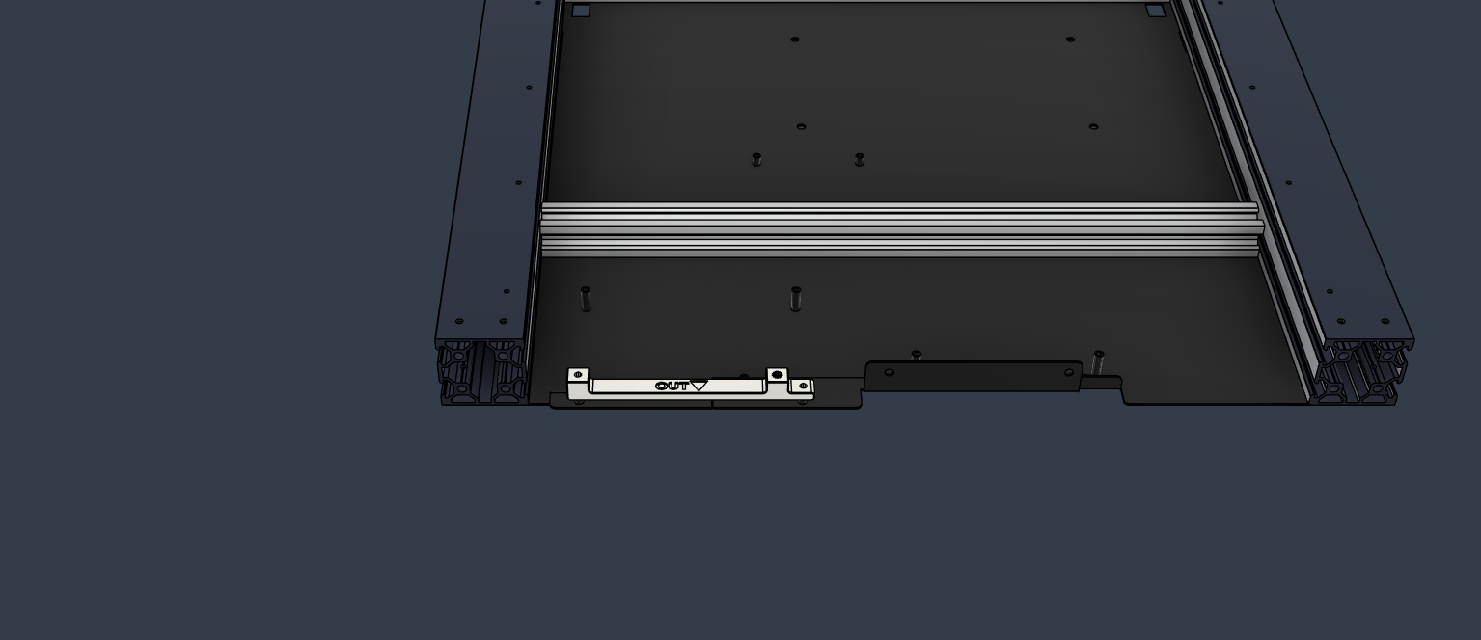

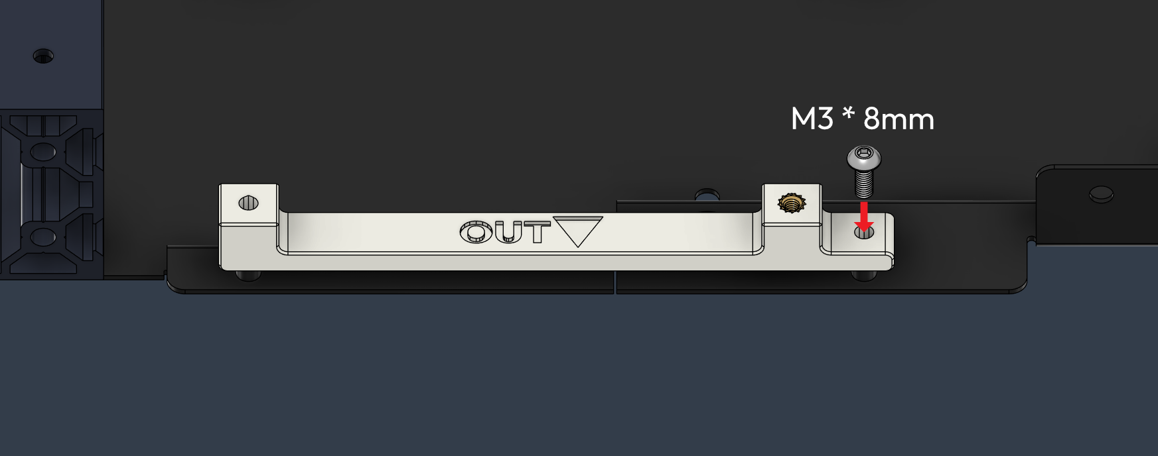

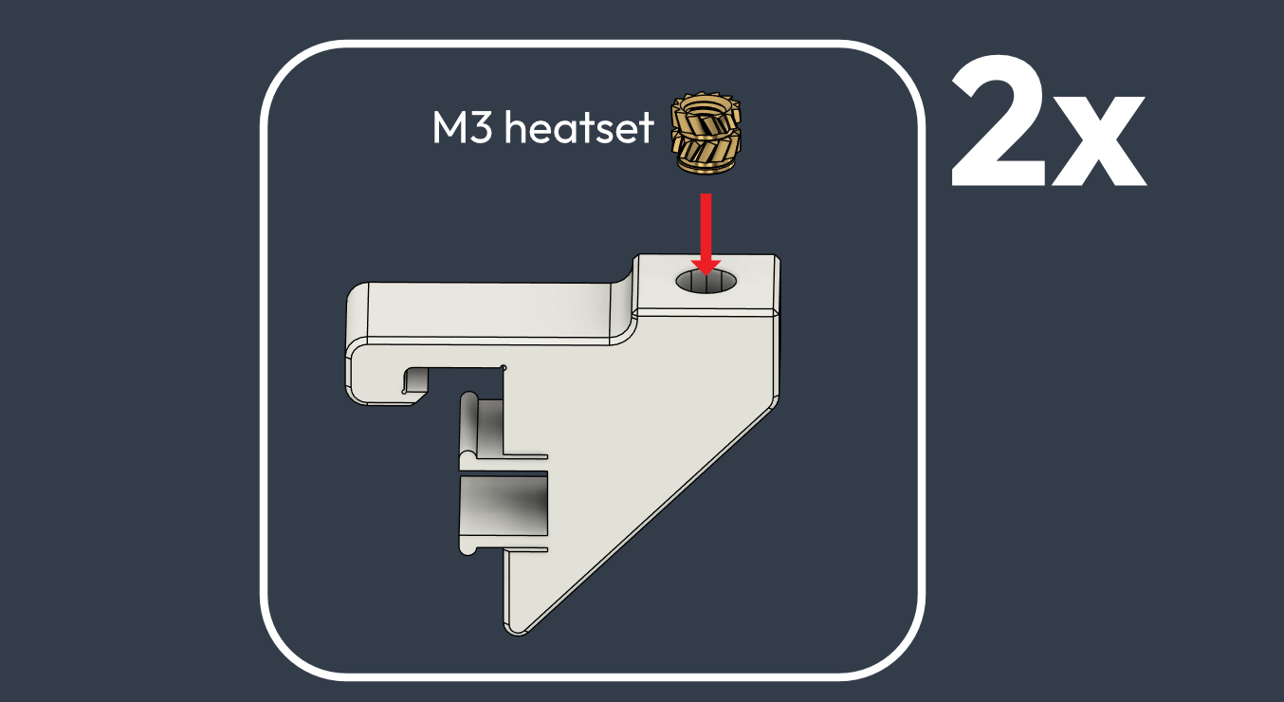

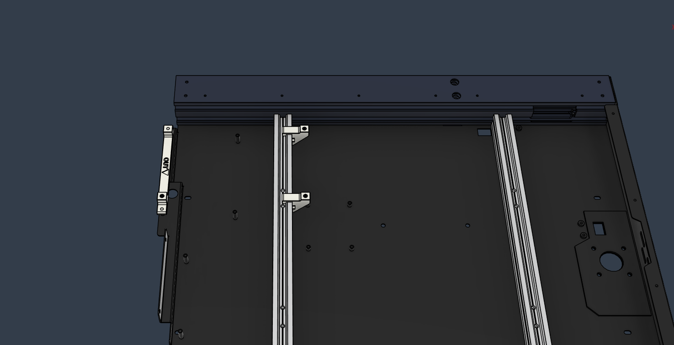

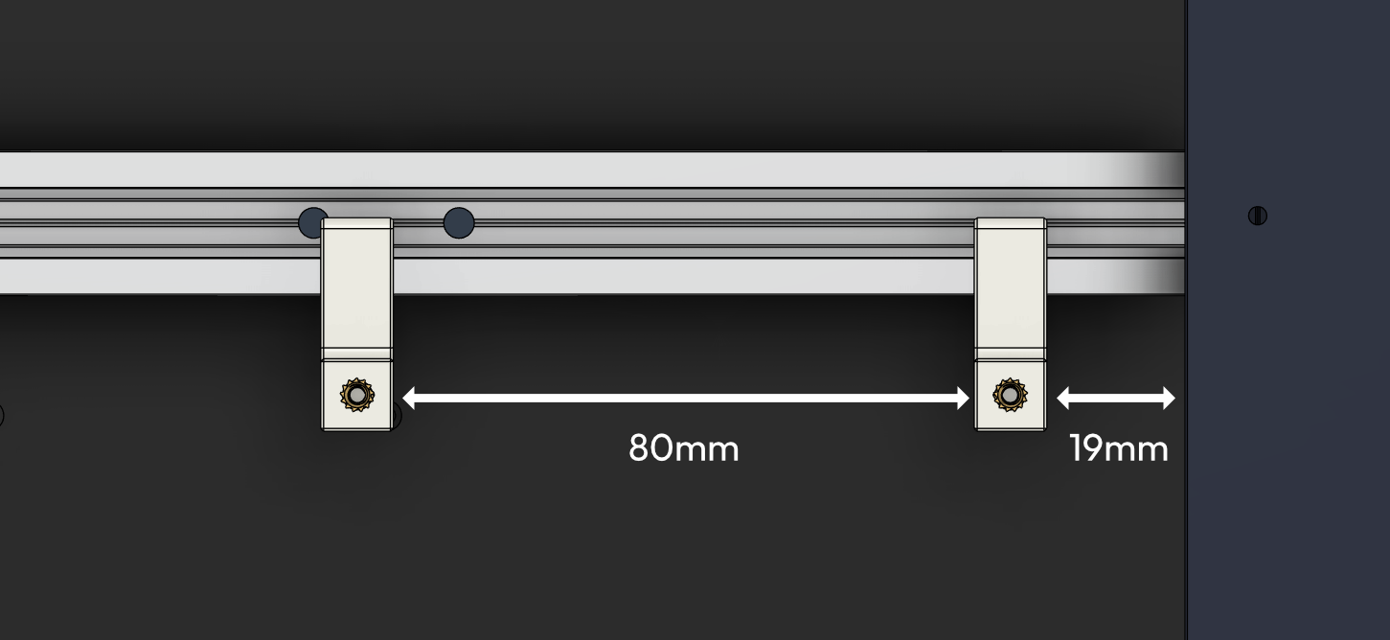

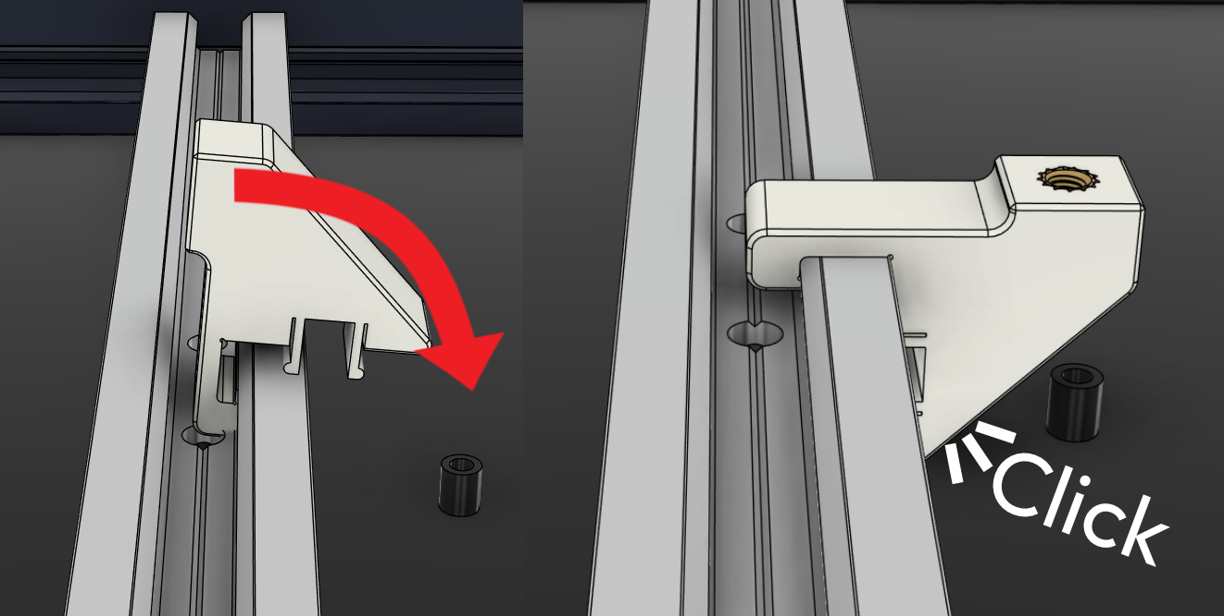

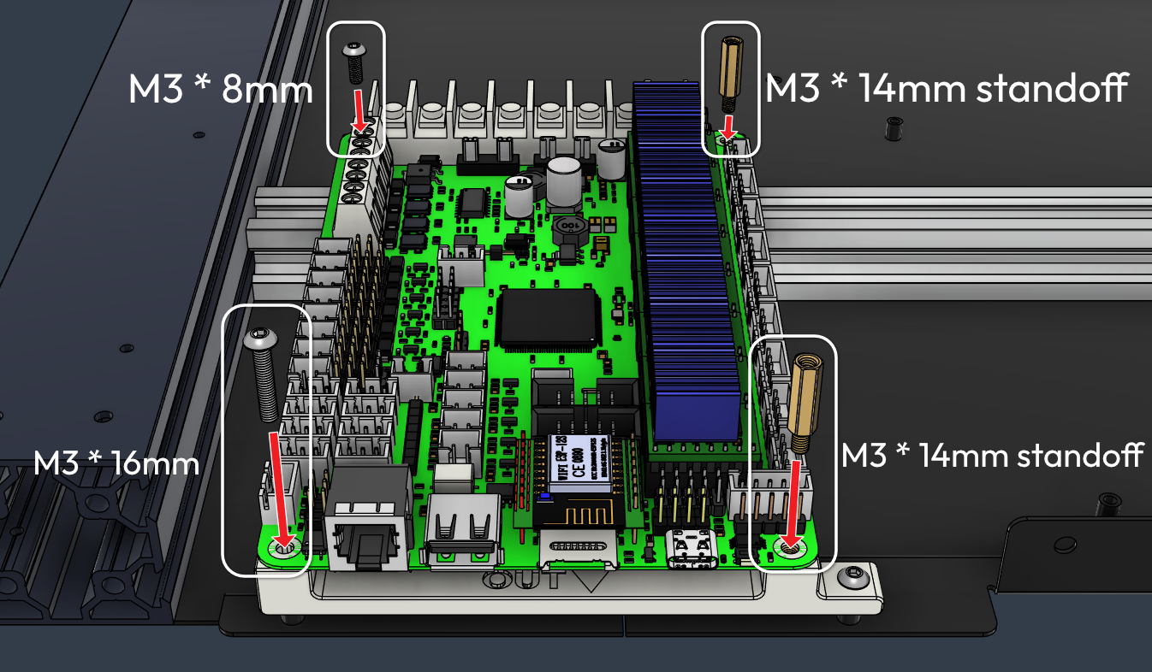

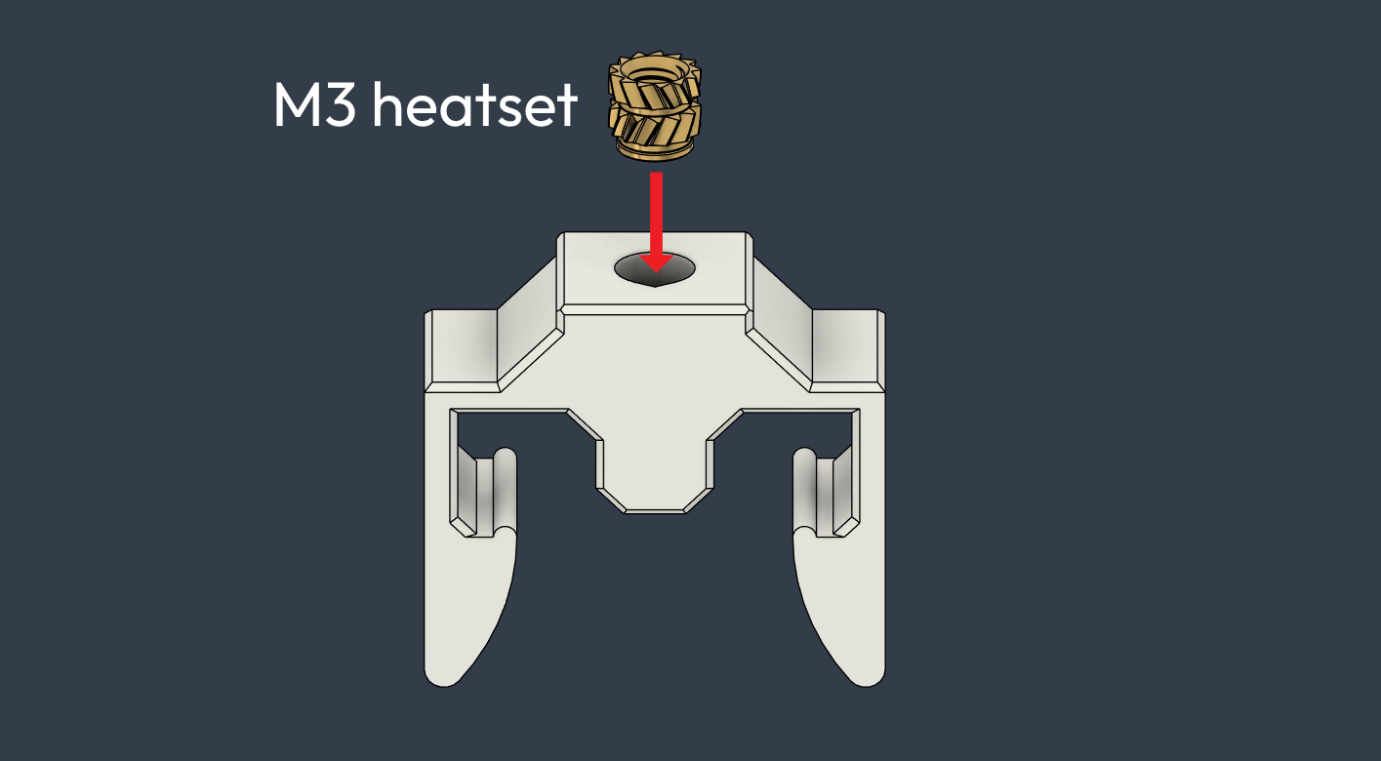

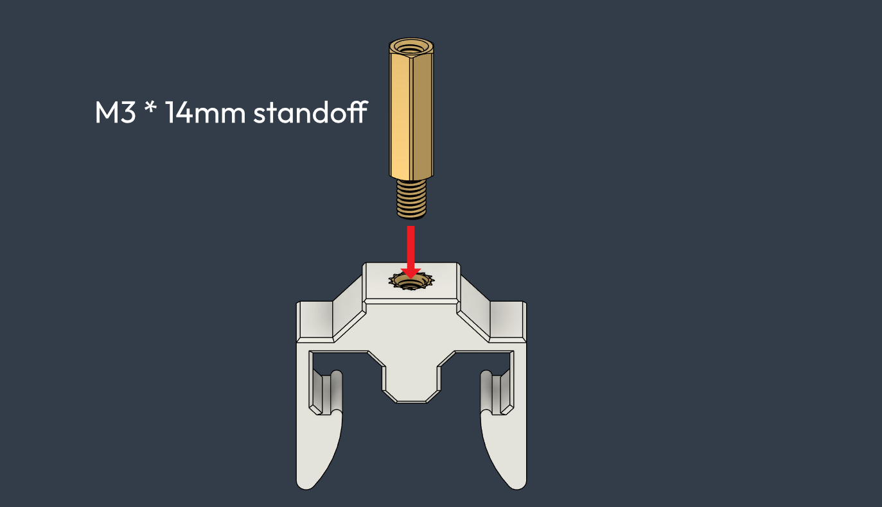

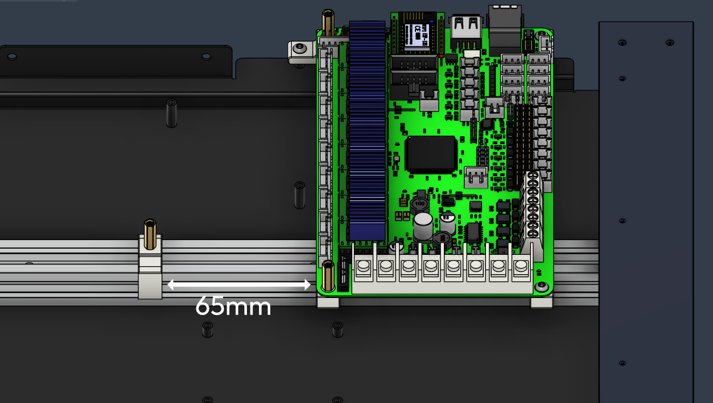

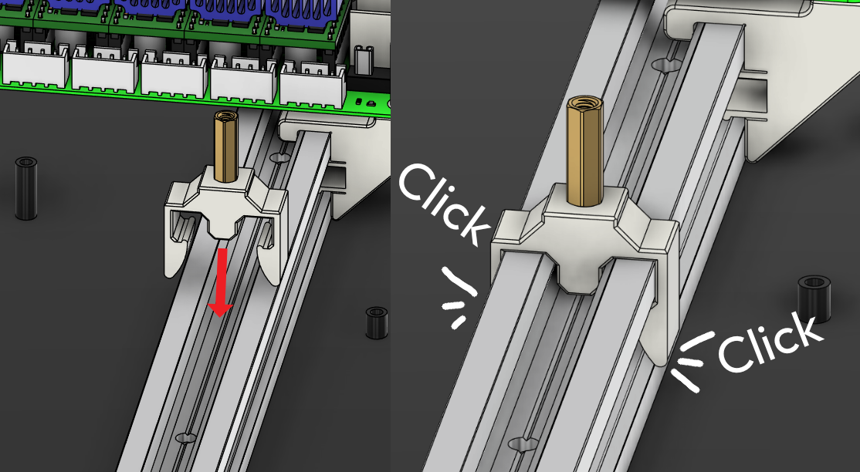

Bottom plate layout (Bandages marked in red)  
Use glue to attach the plates  
